St. Mary’s Pro-Cathedral
Marlborough Street, Dublin 1

Christmas Schedule 2022

~~~~~~~~~~~~~~~~~~~~~~~~~~~~~~~~~~~~~~~~~~~~~~~~~~~~~~~~~~~~~~~~~~~~~~~~~~~~~~~~~~~~~~~~~~~
For unto us a Child is born,
unto us a Son is given,
and his name shall be called
Wonderful Counsellor,
Mighty God,
the Prince of Peace
(Isaiah 9:6)
‘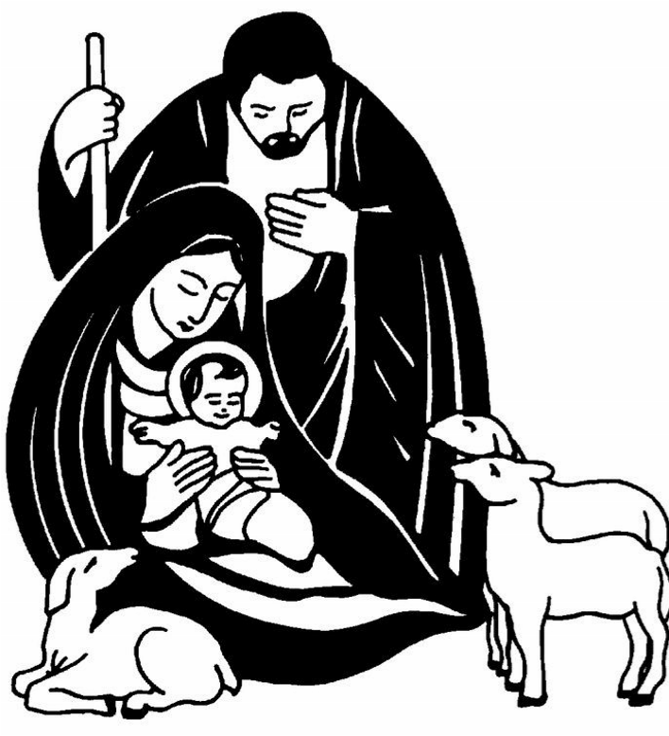
~~~~~~~~~~~~~~~~~~~~~~~~~~~~~~~~~~~~~~~~~~~~~~~~~~~~~~~~~~~~~~~~~~~~~~~~~~~~~~~~~~~~~~~~~~~~

Every blessing for Christmas and the New Year from

Fr Kieran McDermott, Adm.,
Msgr. Lorcan O’Brien, Team Assistant
Deacon Thomas Groves
Fr. Brendan Staunton, S.J., Parish Chaplain

The Nativity of Our Lord

CHRISTMAS EVE
Saturday 24th December 2022

Mass at 9 p.m.
Christmas Carols from 8.30 p.m.
With the Palestrina Choir

CHRISTMAS DAY
Sunday 25th December 2022

Mass at 9.30 a.m.
With St Mary’s Pro-Cathedral Girls’ Choir

Mass at 11 a.m.
With the Palestrina Choir

~~~~~~~~~~~~~~~~~~~~~~~~~~~~~~~~~~~~~~~~~~~~~~~~~~~~~~~~~~~~~~~~~~~~~~~~

Sacrament of Reconciliation

Monday 19th to Friday 23rd December
following the 10.30 a.m. and 12.45 p.m. Masses

Christmas Eve – Confessions 11-2 p.m.

Tuesday 27th to Saturday 31st December 2022
Mass 10.30 a.m.

Solemnity Mary, The Holy Mother of God
Saturday 31st Vigil 6 p.m.

Sunday 1st January 2023
09:30 a.m.
Mass of Peace at 11.00 a.m.
Cathedral open from 9 a.m. to 1 p.m.

Monday 2nd January 2023
(Public Holiday)
Mass 10.30 a.m.
Cathedral open from 10 a.m. to 12 noon

Tuesday 3rd to Thursday 5th January 2023
Mass 10.30 a.m.
Cathedral open from 10 a.m. to 2 p.m.

Friday 6th January 2023
The Epiphany of the Lord [Holy Day]
Mass Times 10.30 a.m. & 12.45 p.m.
Cathedral open from 9.30 a.m. to 4 p.m.

