St Mary’s Pro-Cathedral
Saving Energy, Reducing Costs

WEEKDAY MASSES 10:30 & 12:45
Monday to Friday
St Kevin’s Oratory

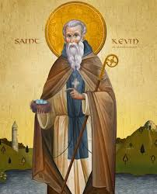

From Monday 7th November please be advised that the daily 10:30 and 12:45 Masses will be celebrated in St Kevin’s Oratory which is adjacent to the Cathedral and can be accessed through the door to the right of St Joseph’s Altar. Exposition of the Blessed Sacrament will take place there from 11:00 am to 12:30 pm.

This change is necessary in order to conserve energy and reduce costs over the winter months.
We ask for your understanding and cooperation at this challenging time.

